## Indian Institute of Information Technology Chittoor, Sri City

Course: **Database Management System**

Duration: **2 hours**

Max. Marks: **20**

Roll No.: S20200010212 __________________________

Name: _RAHUL VARMA________________________________

**Instructions:**

1. Answer all the questions and paste the screenshot in the same sequence in the word file (question paper). Then convert it into the single pdf.
2. The name of the pdf must be your Roll no followed by your name. (Example: S20190990001_XXXXX) Upload single pdf file.
3. Crop only required part in the screenshot. Don’t paste entire screenshot unnecessarily.
4. Consider the Bank database for all the questions.
5. Table data will be shared in the classroom.

**Section -1 (Queries)-5M**

1. The retirement age is 60 years. Display the retirement day of all the Customers. [1 Mark]
2. List the number of customers in each place. [2 Mark]
3. List Customer details who are minor. [1 Mark]
4. Find all the customers who have loan at the bank, but do not have an account at the bank [1 Mark]

**Section-2 (Programs)-15M**

1. Write a stored function to replace the customer name “Smith” to “your roll number”. [5 Marks]
2. Create a Stored procedure to display Net balance of all the customers. [5 Marks]

(Hint: Net Balance= Balance-Loan Amount)

1. PL SQL Program For function to return the grade of the student using cursor (use student table) [5 Marks]

TABLES:

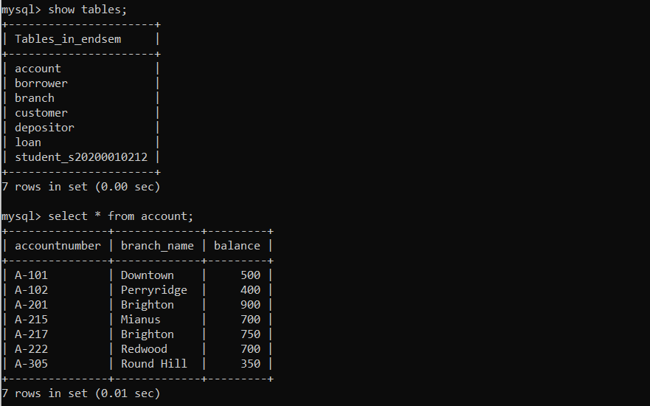

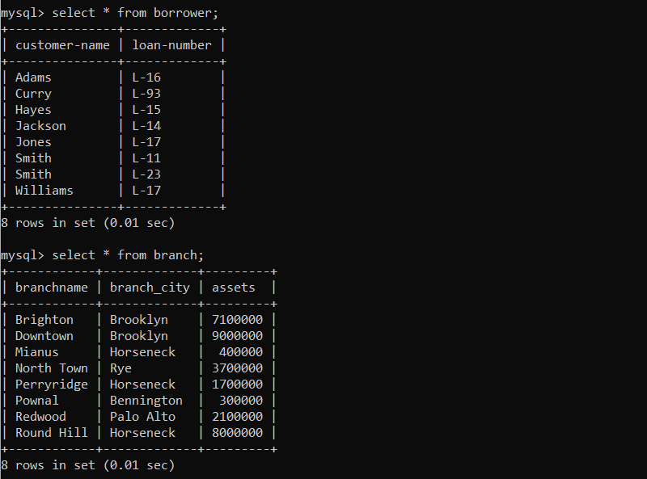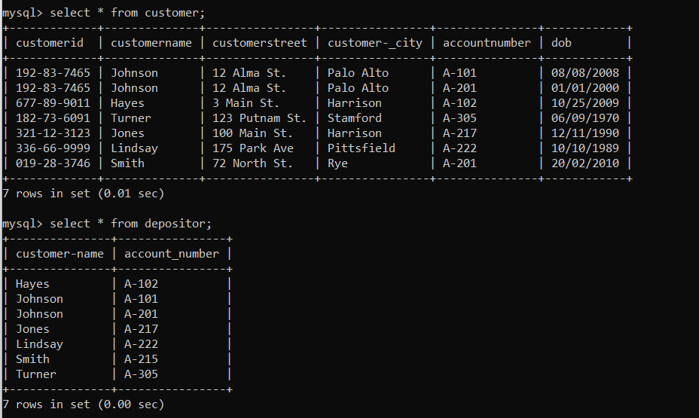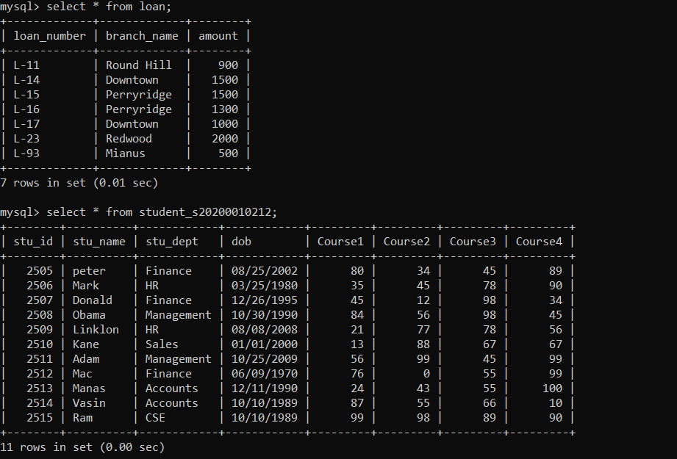

SECTION 1:

Q1)

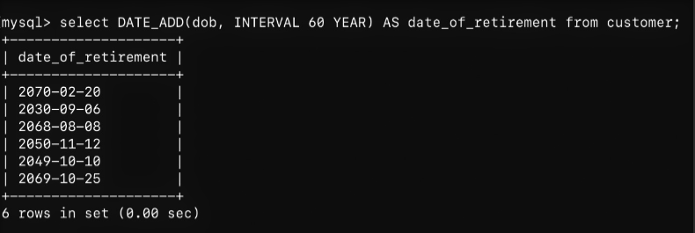

Q2)

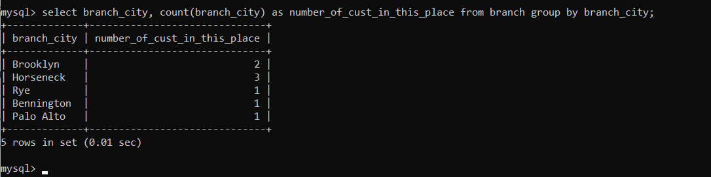

Q3)

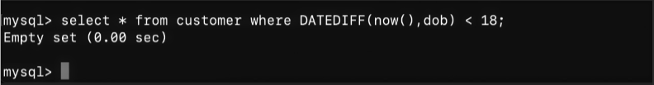

Q4)

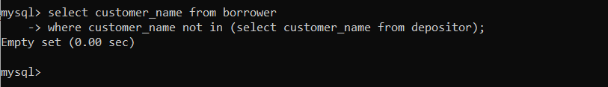

SECTION 2:

Q1)

SMITH IS CHANGED TO MY ROLL NUMBER:

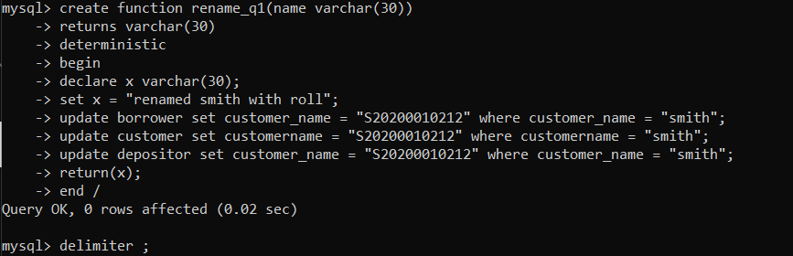

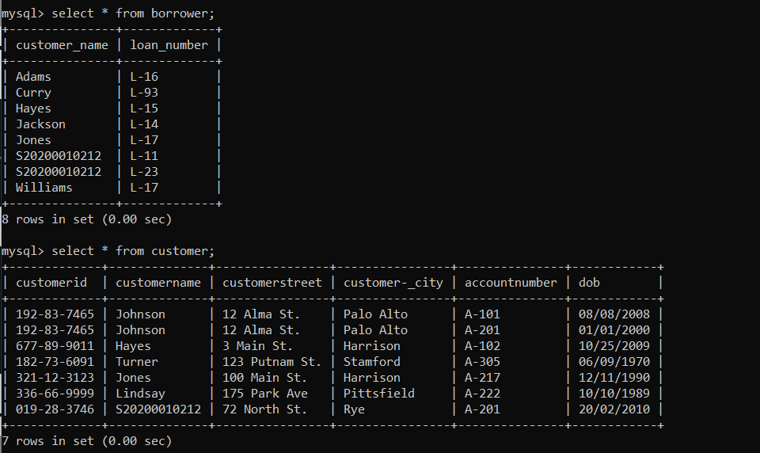

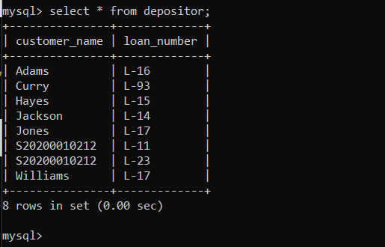

Q2)

) 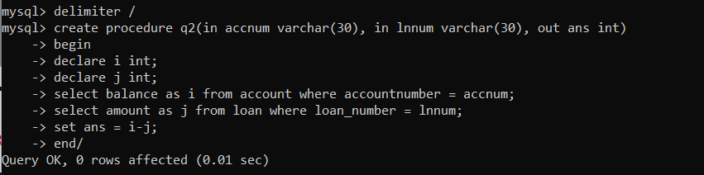

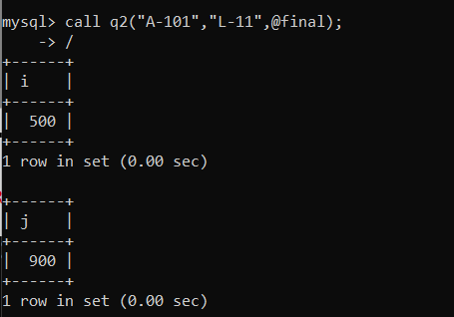

FINAL ANSWER WILL BE -400

SO WE CAN FIND ALL BY PASSING IN FUNCTION

Q3)

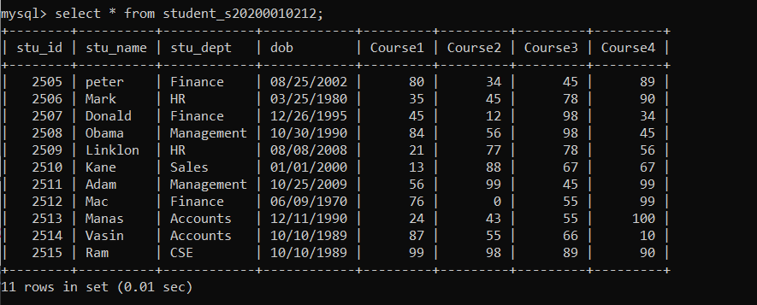

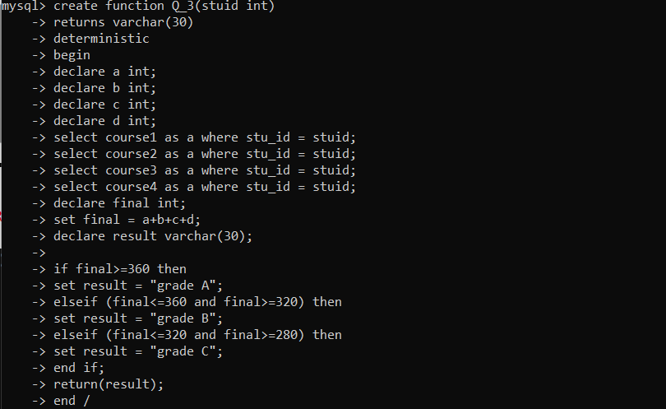

I ADDED THE RESULT IN THE FINAL TABLE

FOR THE GRADES FOR PERSONS

